Home Assignment :Jira Integration
Open VS code
File -New Window
File-Open Folder
E:\Vidhya_Assignment link\August 23rd\rag-mongo-demo-v12\rag-mongo-demo-v9

Give the below Prompt in copilot inside VS code
Act as a Senior Architect

Currently the existing application has ingested the test cases and userstories into Mongo DB. Test cases file and userstories file were converted to JSON file in 'Convert to JSON' section in the application. The converted Json file checkbox was selected under 'Embeddings & Store' section in application and when 'Create Embeddings' button was clicked, the test cases and User stories were injected to Mongo DB. Test cases are getting generated for the user stories in the application. Now we need to integrate Jira with the existing application, fetch the user from Jira, Ingest into MongoDB, Retrieve existing context, generate test cases and display results.

[Mandatory] Integrate ‘Jira’ with existing application
[Mandatory] Fetch the ‘User story’ from Jira
[Mandatory] Ingest the fetched user story into ‘MongoDB’
[Mandatory] Retrieve the existing/relevant context from MongoDB
[Mandatory] Use the Jira user story along with the retrieved context to generate test cases using the existing functionality
[Mandatory] Display the generated test cases in frontend
[Do not] Don’t rebuild the existing ingestion,retrieval,or test case generation functionality.
[Strict] Focus on the Jira integration and connecting it with the existing flow

Convert to Json section in aplication:
The data type dropdown should be displayed with 'Jira' along with the existing drop-down values 'Test Cases' and 'User Stories’. On selecting the Jira story and clicking on 'Convert Jira' button, the selected user story in Jira should be converted to Json format.

Embeddings & Store section in application :
The converted Json file of Jira userstory should be listed. On selecting the checkbox against the Json file and clicking on 'Create Embeddings’, the Jira story should be uploaded in the Mongo db.

Jira test case generation(Create this section newly in the application)'
The user stories available in Jira should be displayed. On selecting a user story and clicking on generate testcases, the test cases should be generated for the selected user story from Jira

Need to create test case to technically validate the functionality
Step 2 :
Create Jira API Key in Jira and make a note of it(Refer July 19th folder to refer steps)
Prompt 2 :
Plan mode :
Need to add "Connect Jira" button to establish the connection
Base URL : https://amvidhya1.atlassian.net/jira/software/projects/KAN/list?jql=project%20%3D%20KAN%20ORDER%20BY%20cf%5B10019%5D%20ASC

Email id: amvidhya1@gmail.com

Jira API key :
ATATT3xFfGF09RgL7D1GT6PSP1gVblz1Z9hjHdrUidNJ_jGcRJ5N_b_VmME-d74zvpd8lOjdwrtstmjxyBZM30OgNHdJt5CKjP1Z4JtSALg1OaAEGEKtLrFVVseeqqNGNlgzucPZY0oiJcyA94XfE3Zz9Hc2I50zQT9cn8twEWmOf0TSiwxoGPY=AB8A0E7C
Add the variables in .env file
Give the below prompt in agent mode
Go ahead with the implementation

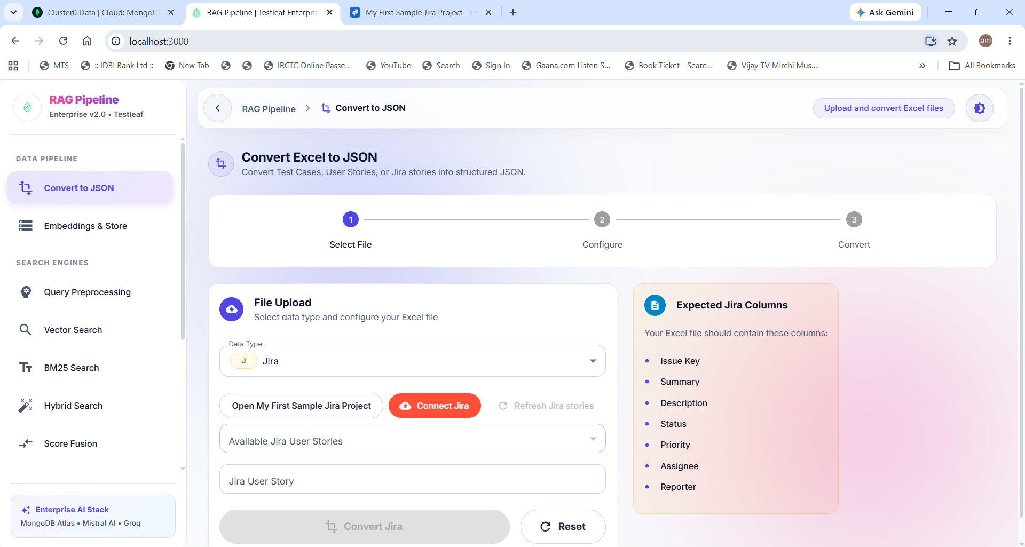
Click on ‘Connect to Jira’ . Select a user story from the drop-down option displayed with Jira user stories.
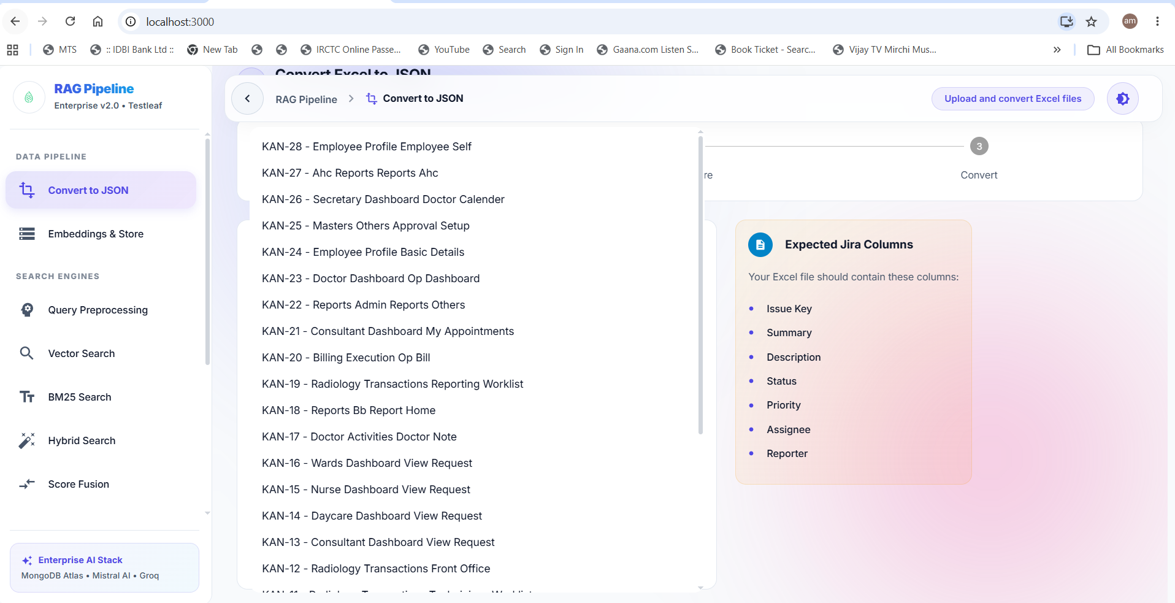
Select one Jira User story and click on ‘Convert Jira’. Conversion will be successful.

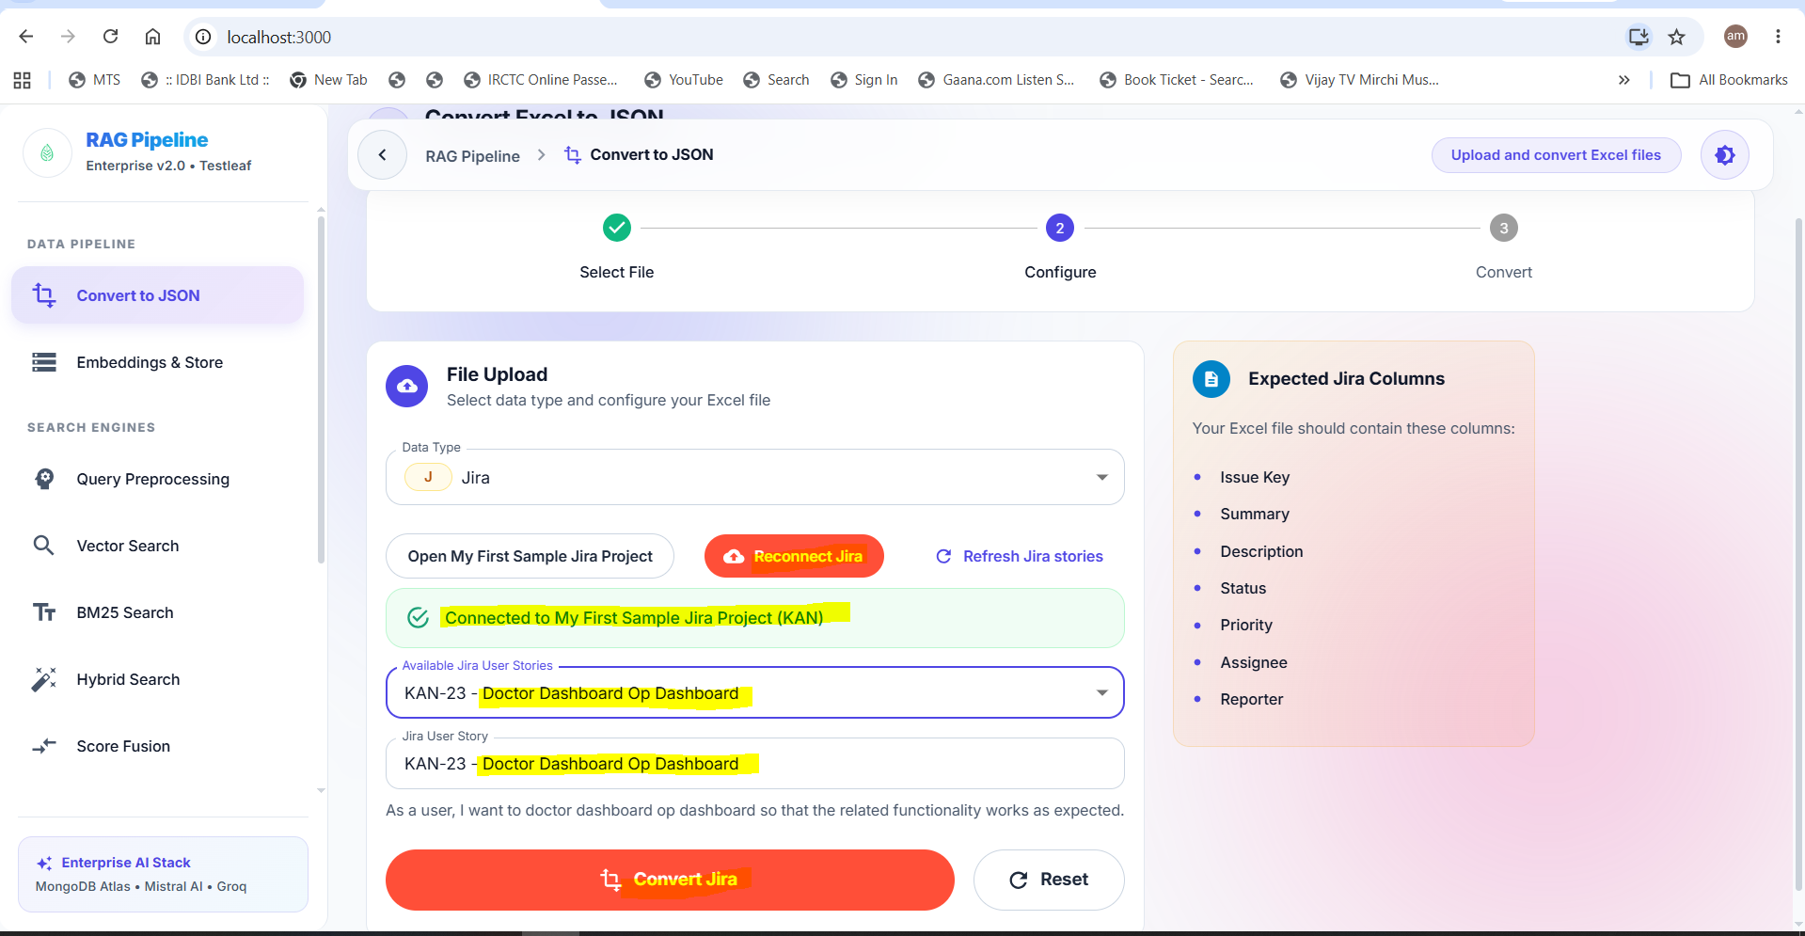
Select the checkbox against the converted Json Jira user story
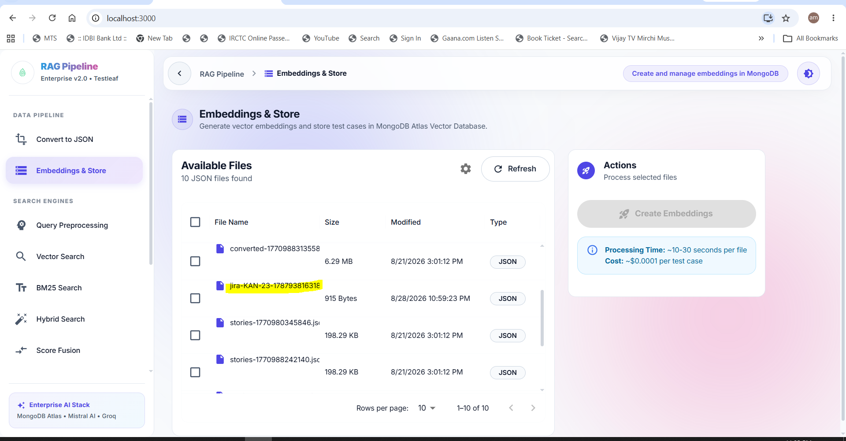
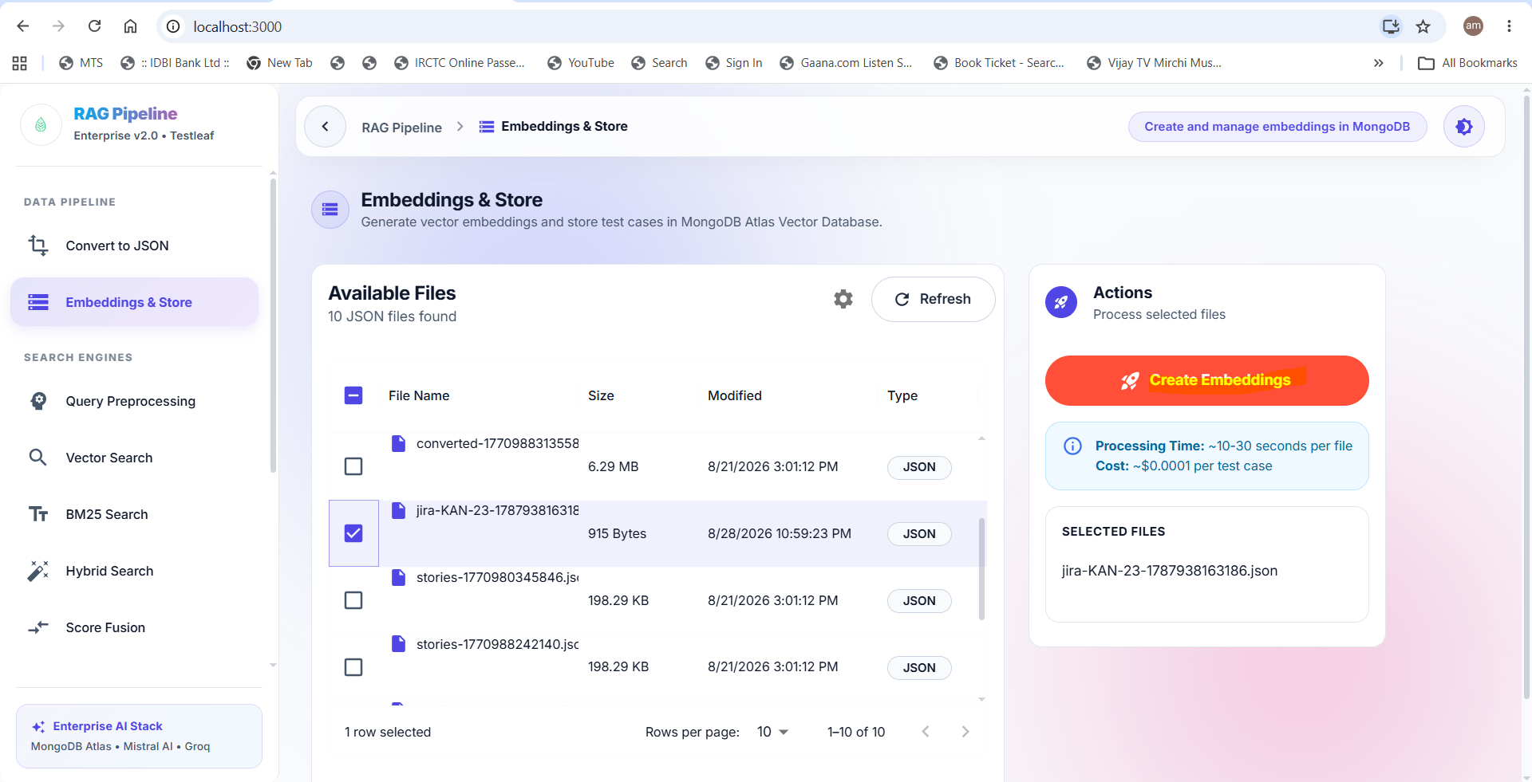
Navigate to ‘Jira Test Cases’ and select the Jira user story and click on Generate test cases.
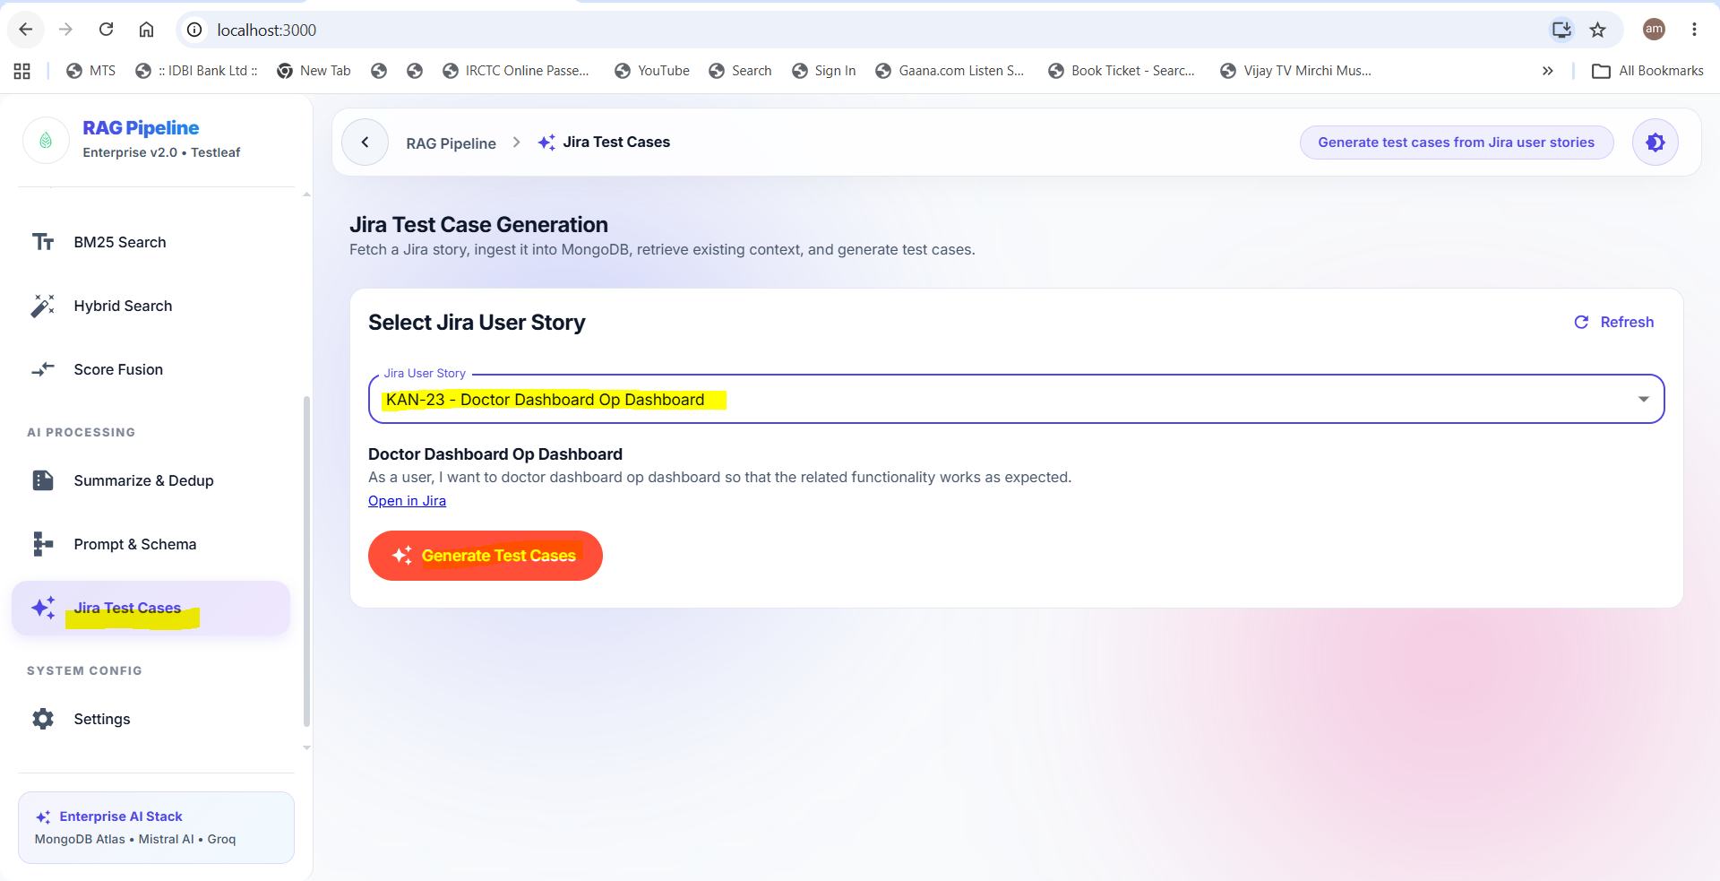
Select the number of test cases the need to be generated
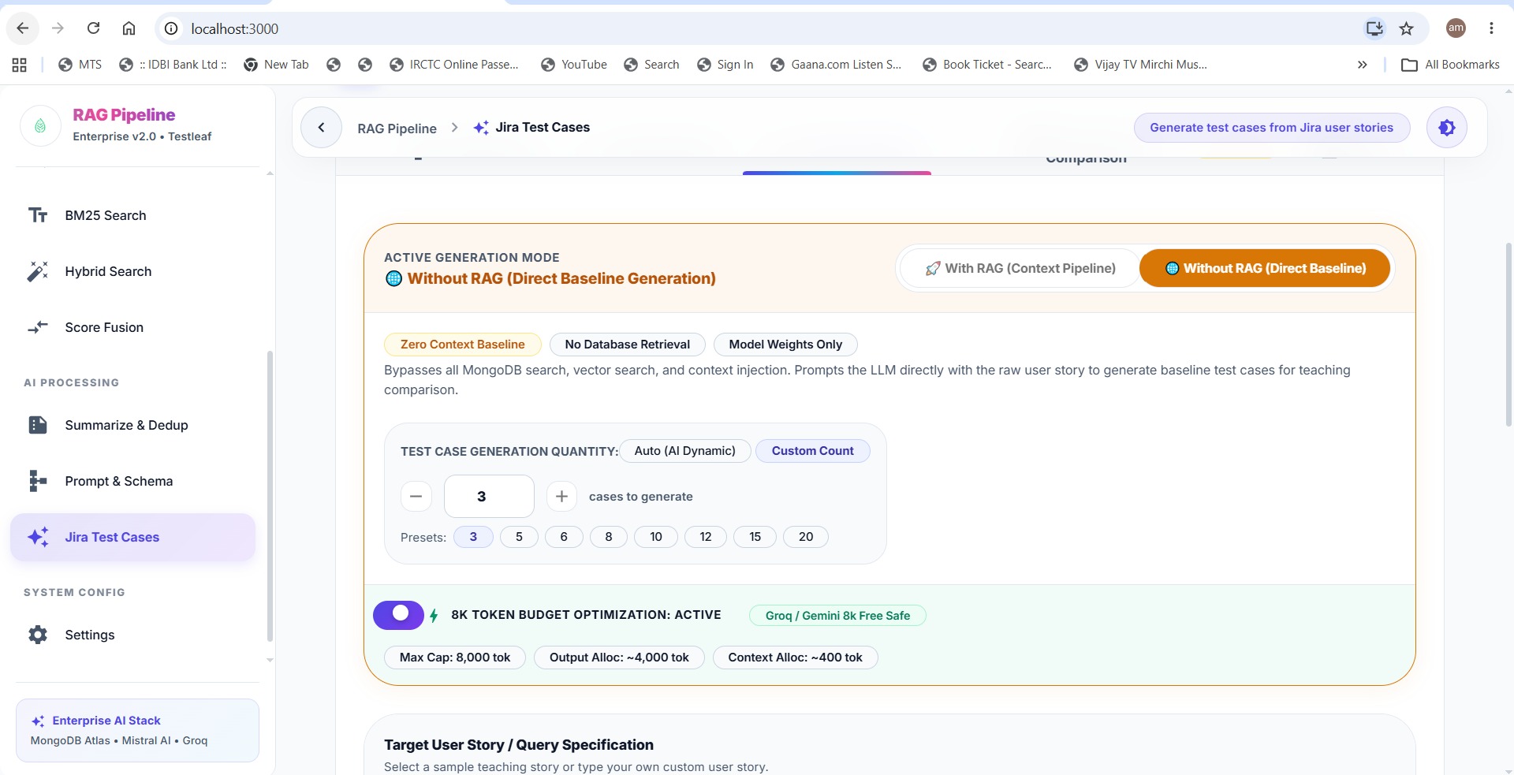
Click on Generate Test cases. Test cases will be generated for the selected Jira user story
